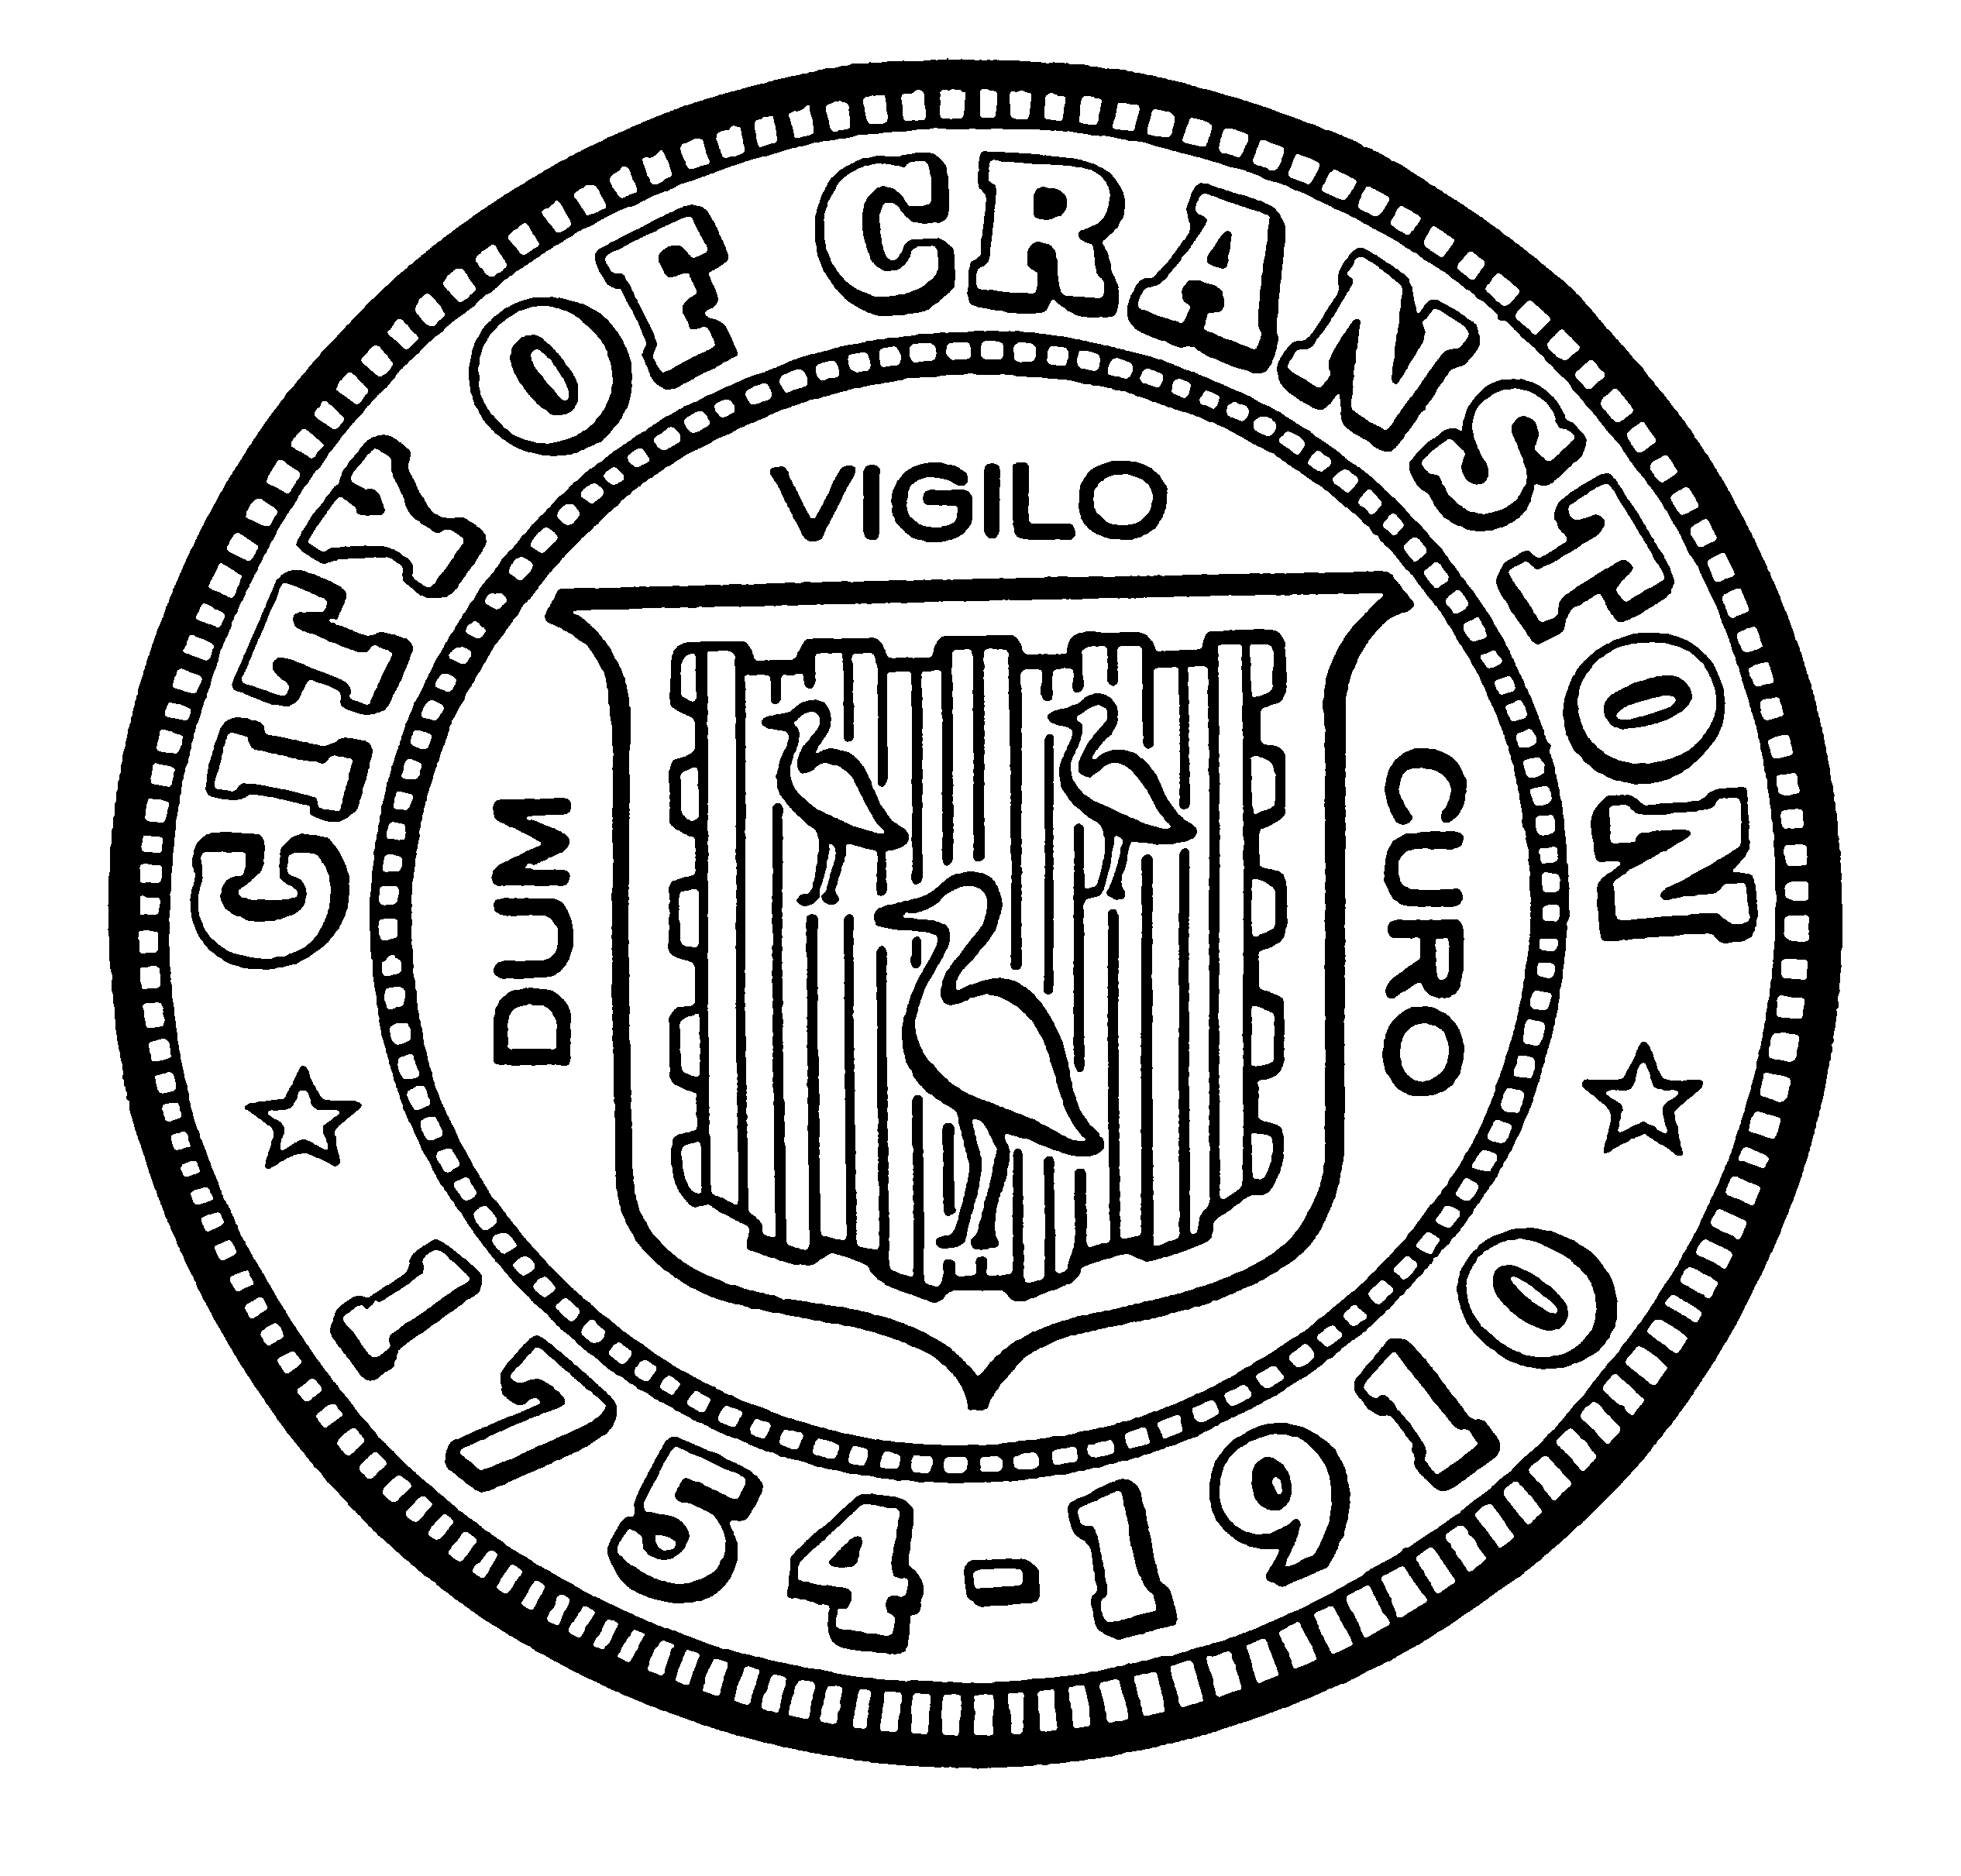

HOUSING COMMISSION

Annette Mann Bourne, Chair
Laura-Jean Ferranti, Community Development (interim)
Amy Rainone, Secretary
Jason Case
Frank DiZoglio III
Joanne McGunagle, CCAP
Jason M. Pezzullo, Planning Director
Robert Santurri Jr, OneCranston Health Equity Zone
Derik Tutt

WEDNESDAY July 6, 2022 @ 5:30 P.M.
Cranston City Hall, 869 Park Avenue
3rd Floor Conference Room

MONTHLY MEETING- MAY AGENDA

- Approval of minutes of May 4, 2022 meeting (for vote)
- Nomination of new Vice Chair (for discussion and possible vote)
- Discussion of presentation to the City Council (for discussion and possible vote)
- Report out on feedback regarding Code Inspection calls and discussion on next steps regarding the Certificate of Safe Occupancy or other actions related to improving the health and safety of Cranston housing stock (for discussion and possible vote)
- New business (for discussion)

“Individuals requesting interpreter services for the hearing-impaired must notify the Office of the City Clerk at 461-1000 Ext. 3197 seventy-two (72) hours in advance of the hearing date.”

